About section Changings:
Circle 1:
Add a small golden line and then white bold heading.
Line 1: ABOUT CONX ORBIT
Line 2: Technology Should Understand the Work It Is Built For.
Circle 2:
Understand the workflow. Build around it. Make it work better.
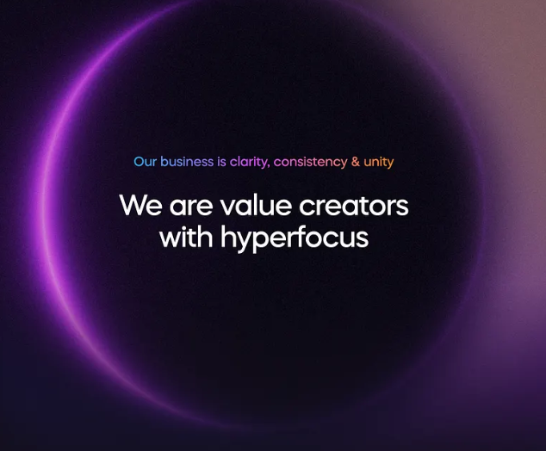
- Add Linkedin Profile link on Founders profile like the image below
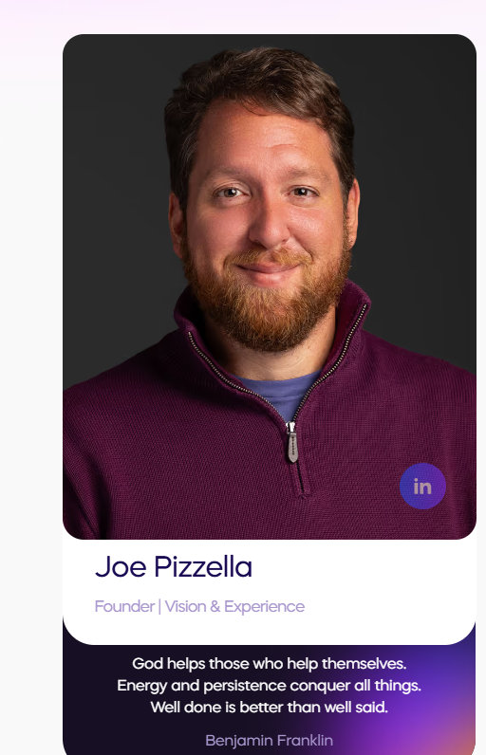
- Change the design of Our story section. Make it creative a bit. Currently it looks like a page of book.
This is the content for Our story Section:
Construction and façade teams work with enormous amounts of information — drawings, specifications, quantities, documents, fabrication data, site updates, and countless decisions. Yet much of that work still depends on disconnected tools, spreadsheets, repetitive processes, and manual coordination.
We saw an opportunity to build technology differently.
ConX Orbit started with a focus on understanding the work before building the technology. Instead of forcing teams into generic software, we work closely with real workflows to identify where information gets lost, where repetitive work slows teams down, and where AI and automation can genuinely make a difference.
Today, we work directly with companies to build custom platforms and intelligent systems around their operations. At the same time, we're developing our own products around recurring challenges we see across the industry.
Our direction is simple: build technology that understands the industry, solves real problems, and makes complex work easier to move forward.
--------------------------------------------------------------------------------------------------------------
Book a Discovery call Page.
Badge:
BOOK A DISCOVERY CALL
Heading:
Let's Understand What You're Trying to Improve.
Paragraph:
Tell us about the workflow, bottleneck, or idea you're exploring. We'll use the conversation to understand how your team works and whether AI, automation, or a purpose-built system can make a meaningful difference.

